Concur
Reference Guide
Mobile Applications
03/22

Table of Contents
Concur for Mobile 2
TripIt Mobile Application 4
Concur App Center 6

Concur for Mobile
Concur for Mobile complements the web-based solution, allowing you to manage your request, travel, expense, or approvals (if applicable) wherever you are. From booking and managing itineraries to capturing receipts and submitting expense reports, you can now do it all in one app with Concur.
With the SAP Concur app, you can:

• Manage the entire request, travel and expense process on-the-go
• Book a flight / hotel / car quickly and easily from anywhere
• Never lose another receipt when you capture/store photos of your receipts
• Quickly review and approve reports and travel requests
• Add attendees to business meetings or meals
• See customized hotel suggestions
• Access and manage your itinerary on the road
• Integrate your itinerary with the TripIt app

Signing into SAP Concur Mobile App
There are two ways to set up the Concur Mobile App. This can be done using the online platform or directly on your mobile smart phone.
To set-up access to Concur Mobile App – using online web based platform:
- In Concur, click Profile > Profile Settings > Concur Mobile Registration.
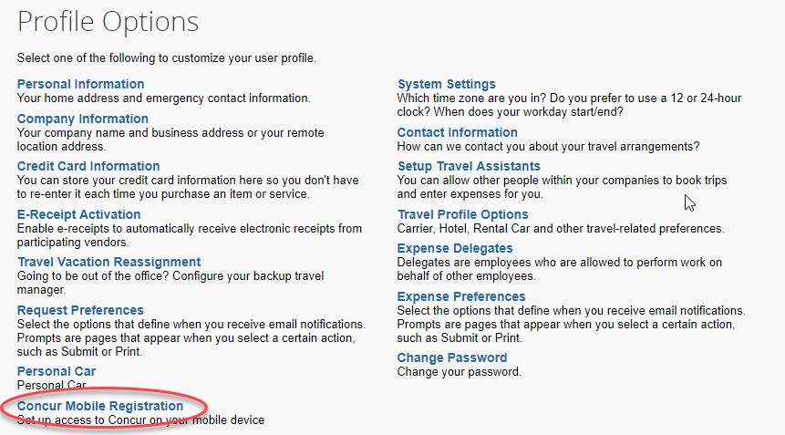

- Enter campus email and click the get started button. This should generate an email with instructions on how to download the app. Take note of the company code.
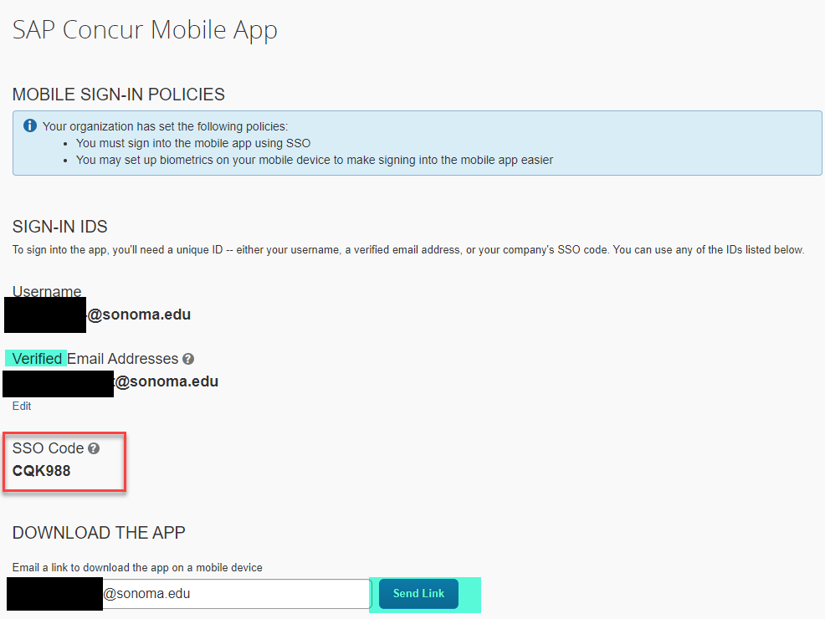

- Download and open SAP Concur mobile app.
- Sign in your work email address or the company code. Select Sonoma from the list of CSU campuses and then enter the credentials you use everyday to access your work computer/devices (SSO).

To set-up access to Concur Mobile App – using phone:
- Download app from the app store on your phone.
- Open app and enter your Sonoma email address. If you are having issues signing in with your work email address.
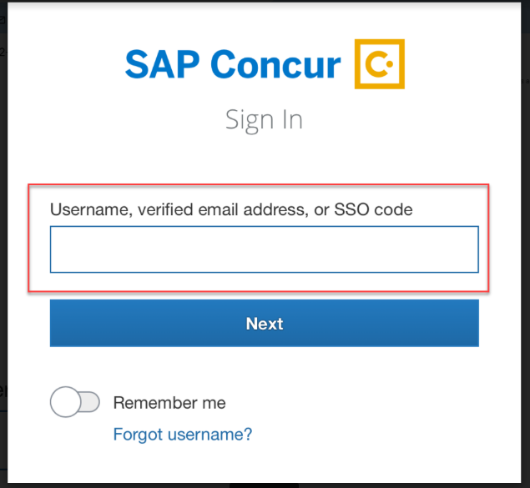

- Enter company code located in profile above.
- Select Sonoma from list of CSU campuses
- Enter credentials you use every day to access your work computer/devices (SSO)
TripIt Mobile Application
TripIt® from Concur instantly organizes all your travel plans in one place. Simply forward travel confirmation emails to plans@concur.com and TripIt will create a master itinerary for each of your trips. Now you can access your plans anytime, anywhere.
Key Features:
- After booking, simply forward your confirmation emails to plans@tripit.com and TripIt will instantly create a master itinerary for each of your trips. If trips were booked in Concur, they will automatically flow to Tripit.
- Access your travel plans on your smartphone, tablet, computer, or wearable device anytime, anywhere.
- Sync TripIt with your calendar, so your travel plans show up alongside other meetings or events.
- Easily share specific plans, or your entire itinerary, with anyone.
- Real-time flight alerts, seat tracking, alternate flight finder, fare refund notifications, point tracking, and more.

Signing into Tripit Pro
Once you are in Concur, you click the App Center, then click the Tripit App Icon.
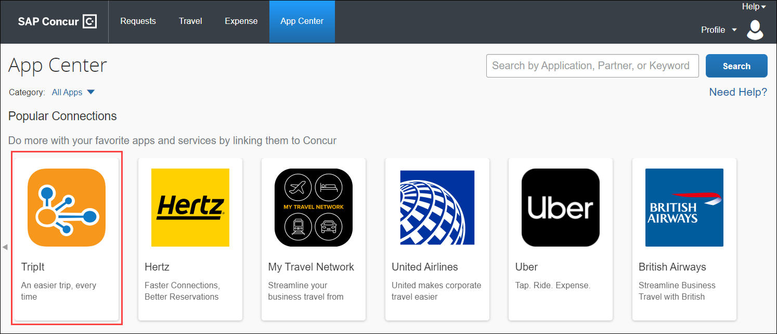
Click the blue Connect button.
Check the box next to Concur App Center End-User Terms and Conditions and then click the blue I Agree button for the Terms & Conditions.
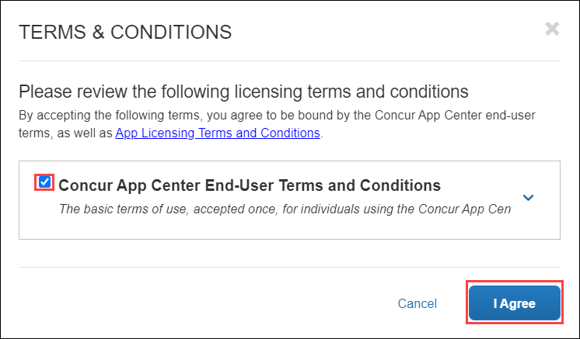
Create a New Password for the Tripit App and check box accepting the terms and conditions. Then click the blue Create Tripit Account. If you already have a Tripit Account, click the orange Sign in link and follow the instructions to connect your account to Concur.
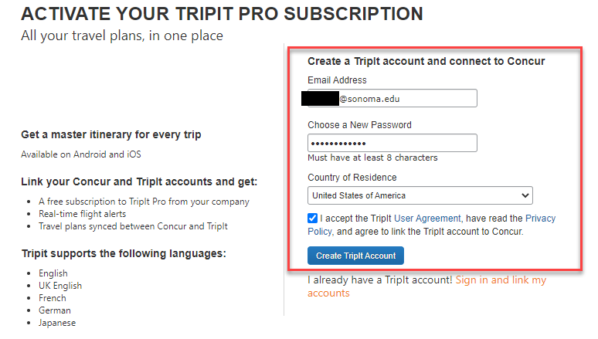
An email will be sent from Tripit to verify the email address entered. Open the email and click Verify Email.
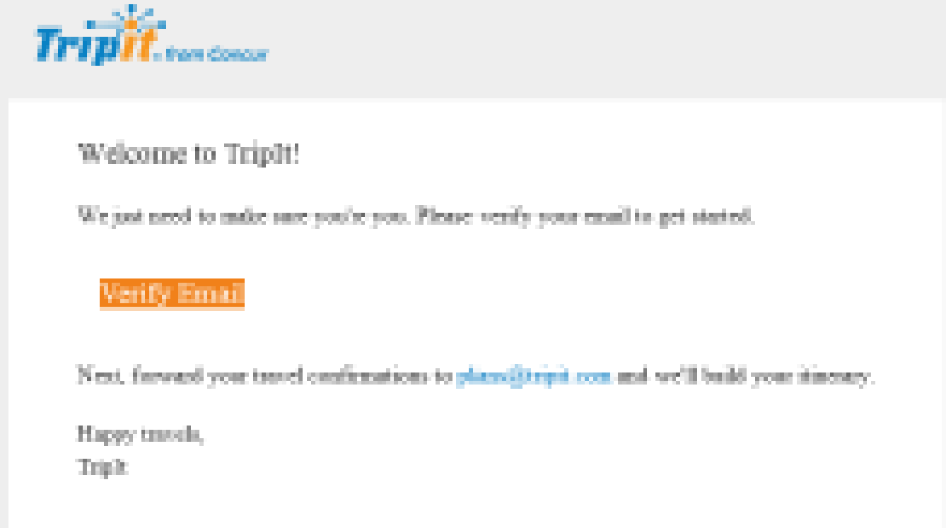
Tripit now should be connected to Concur. If the account did not link, click Connect and at the bottom of the Active Screen click the orange Sign in and link my accounts. Enter in the Email address and the password you created and then click Link my Accounts. Close the window.
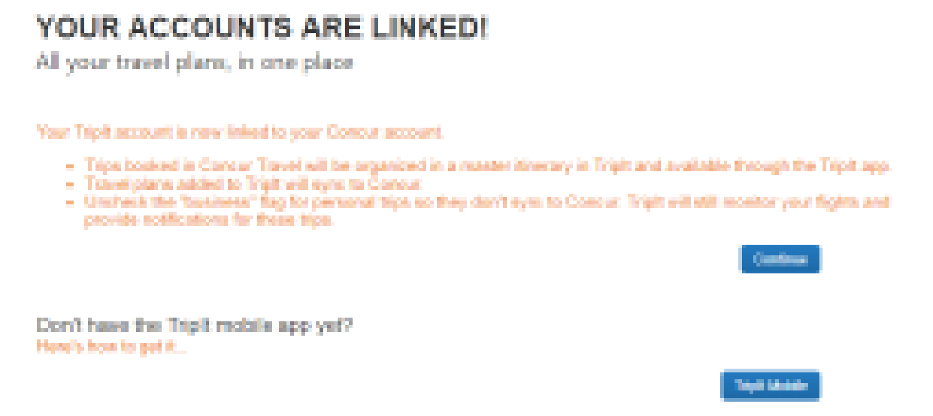
Concur App Center
Concur has many travel partners. As such, there are many partner relationships with company specific applications that can be utilized and connected to your Concur profile for business transactions.
As an example, a traveler can connect their business ground transportation account to Concur. As the app is used to secure transportation (i.e. Lyft) the related receipt will be automatically stored in the travelers list of available receipts that can be used to recall and support trip expenses.
To connect business applications visit the Concur App Center when logged into Concur.
Once you are in Concur, click the App Center, then search for a specific app, or choose an app category:
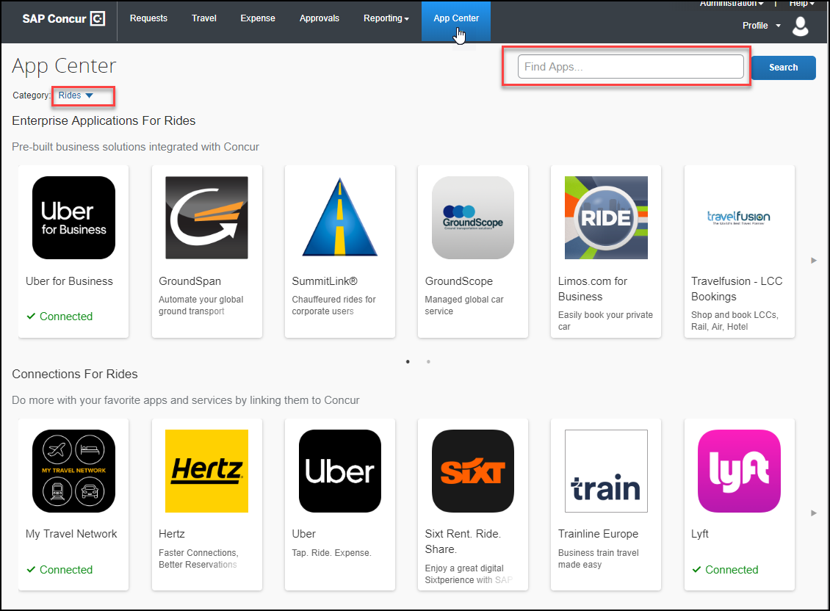

Once a specific app is selected, click the blue Connect button and follow prompts to finish connection. Once done you should see that the app shows connected like in the example below.
